LAB FILE -ADVANCED COMPUTER NETWORKS
PCS223

Submitted by – ARYAN KUHAR
8025320023
ME – CSE
Group - CS1



Computer Science and Engineering Department
TIET, Patiala
2026
ASSIGNMENT 1
To capture live network packets using Wireshark and identify basic network protocols such as TCP, UDP, IP, and DNS.

Start Packet Capture:
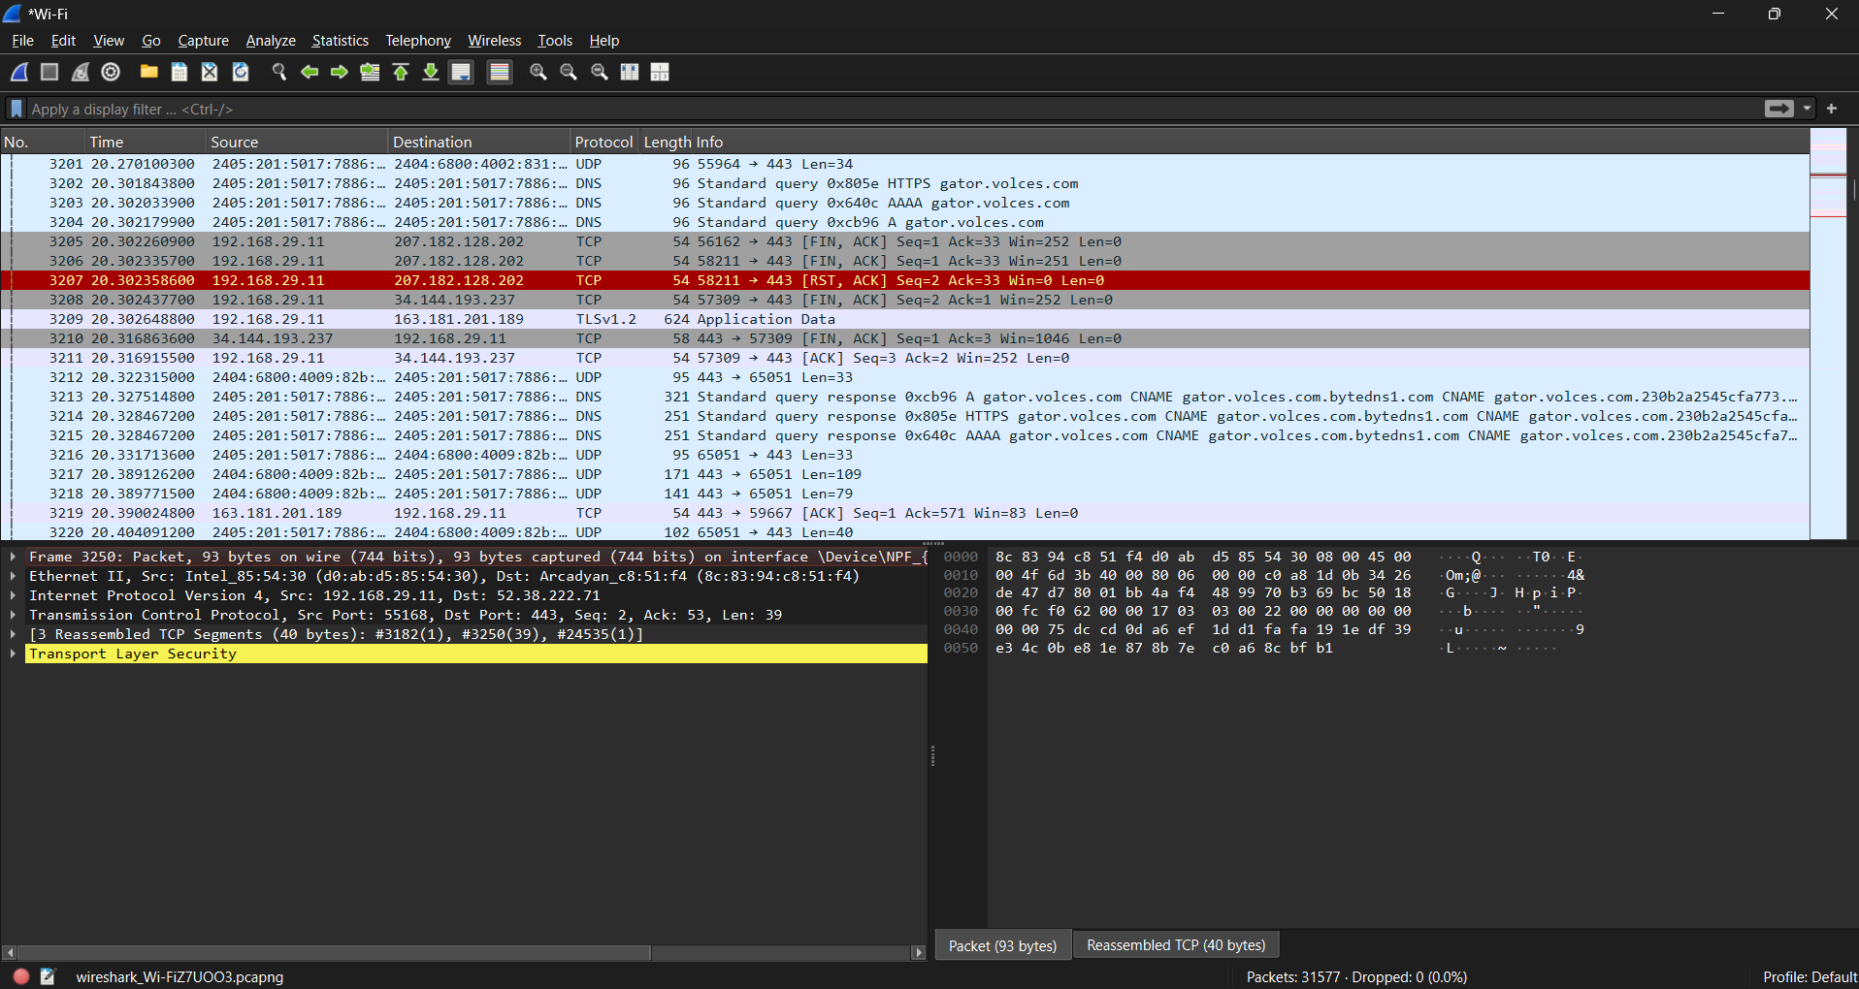

Generate Network Traffic
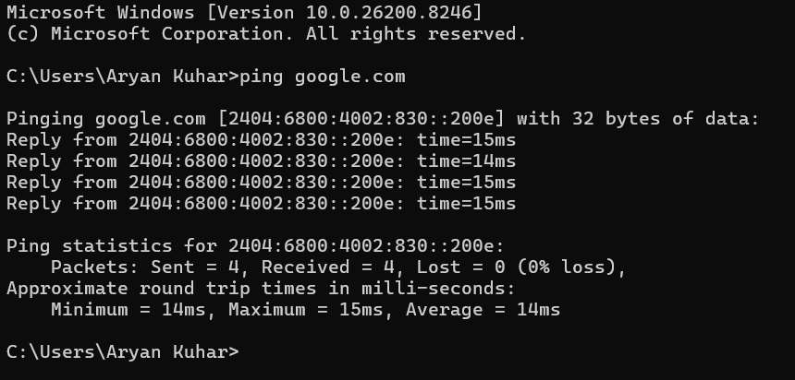

Apply Basic Filters
Use the Display Filter bar:
Filter | Purpose
ip | Show IP packets
tcp | Show TCP packets
udp | Show UDP packets
dns | Show DNS packets
icmp | Show ping packets

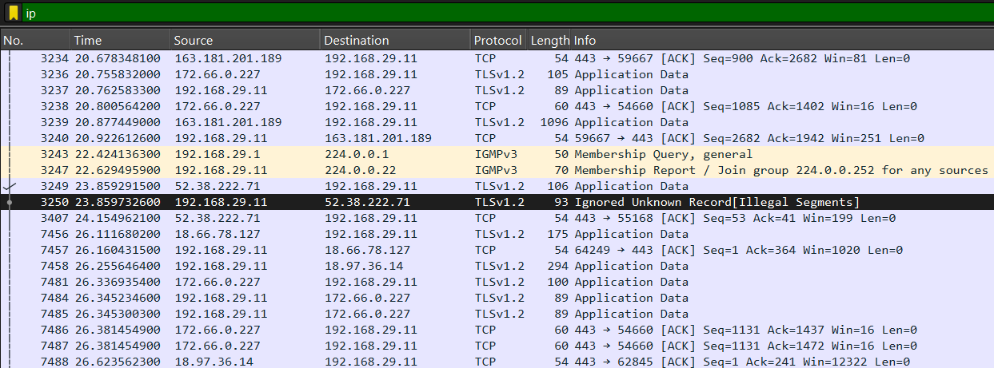
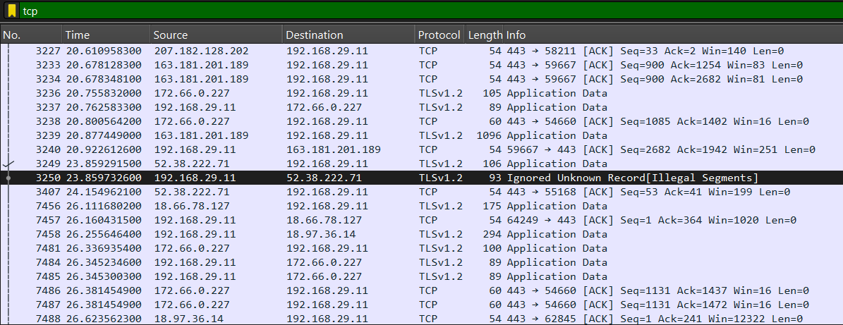
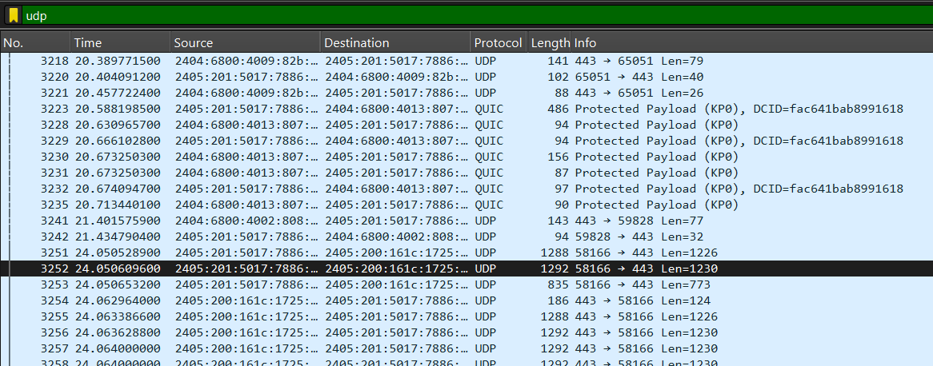
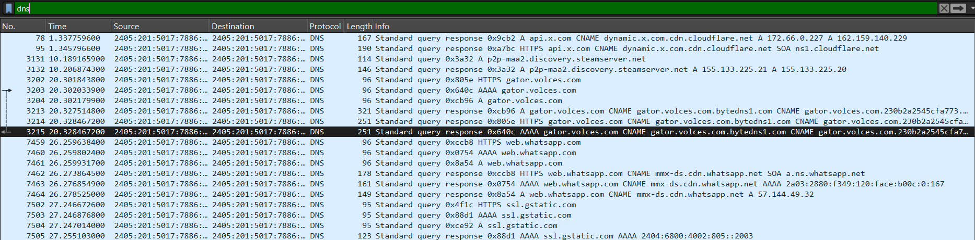

Analyze a Packet
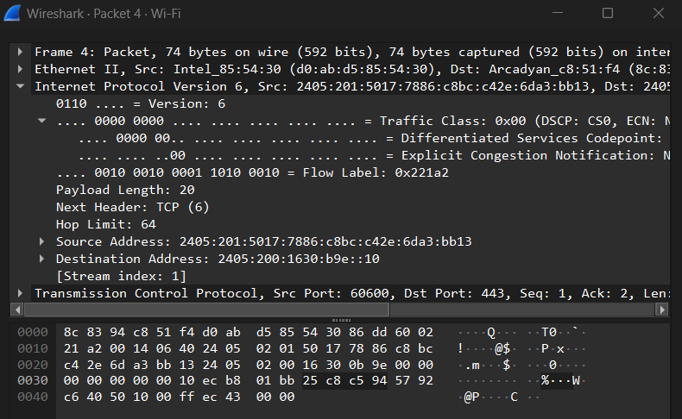

- Observe:
  - Ethernet header-
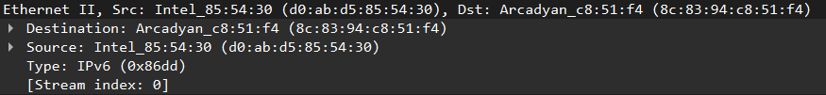
  - IP header-
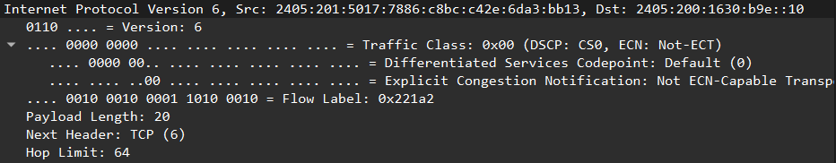

  - TCP/UDP header-
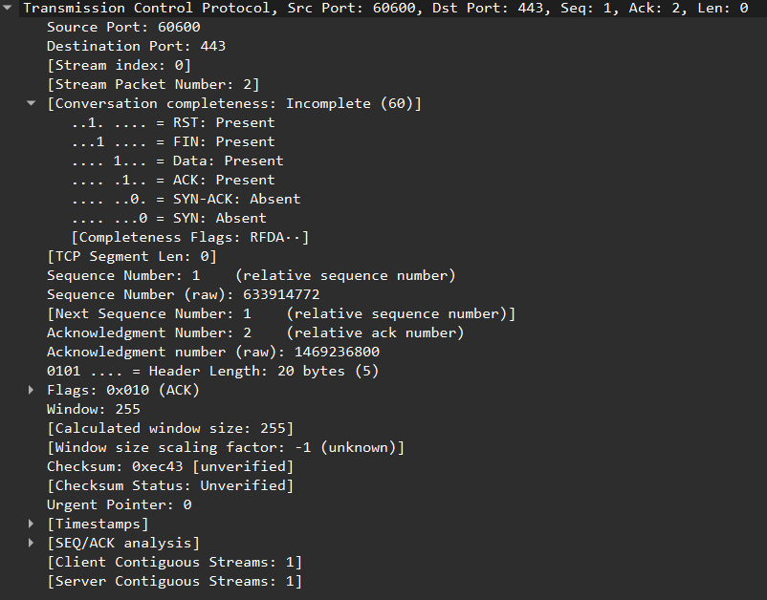

  - Payload data-
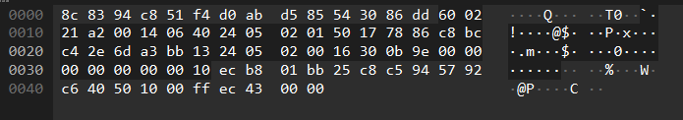

Observation
- Interface used: - Wireshark
- Protocols observed: TCP
- Source and destination IP addresses:
Source: 2405:201:5017:7886:c8bc:c42e:6da3:bb13
Destination: 2405:200:1630:b9e::10
- Packet length: 74 bytes

Result
Live network packets were successfully captured using Wireshark, and basic network protocols were identified and analyzed.

ASSIGNMENT 2

    - To capture and analyze ICMP packets (Ping request and reply)
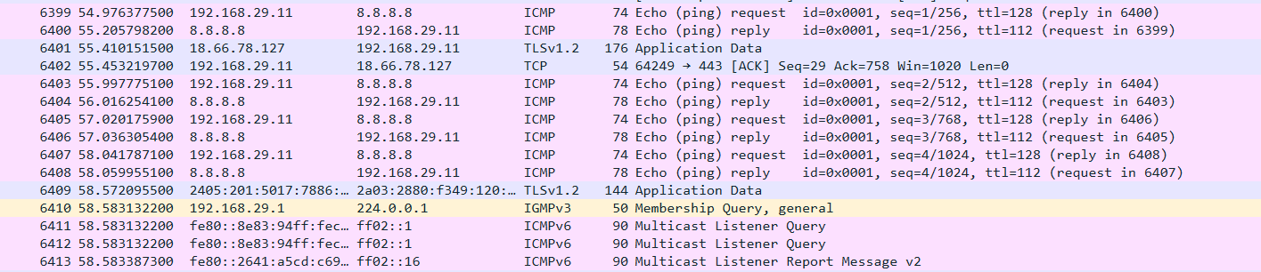

Request ICMP Packet:
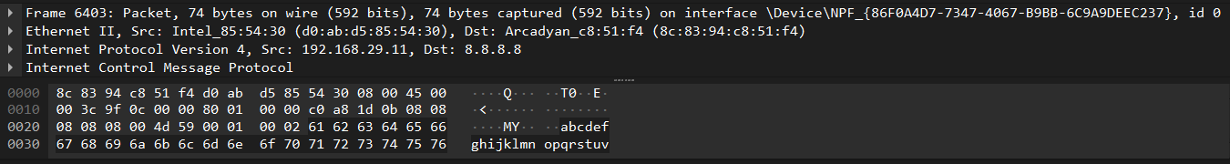

Reply ICMP Packet:
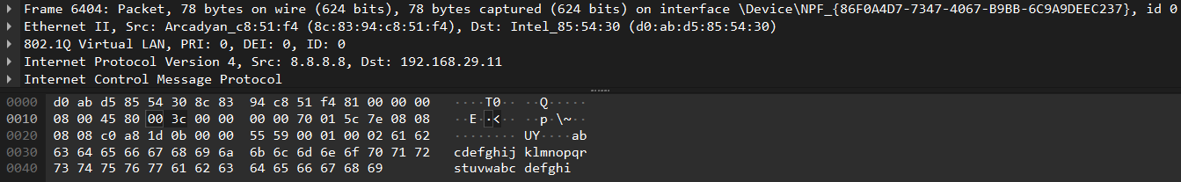

    - To analyze TCP packets and observe the TCP three-way handshake
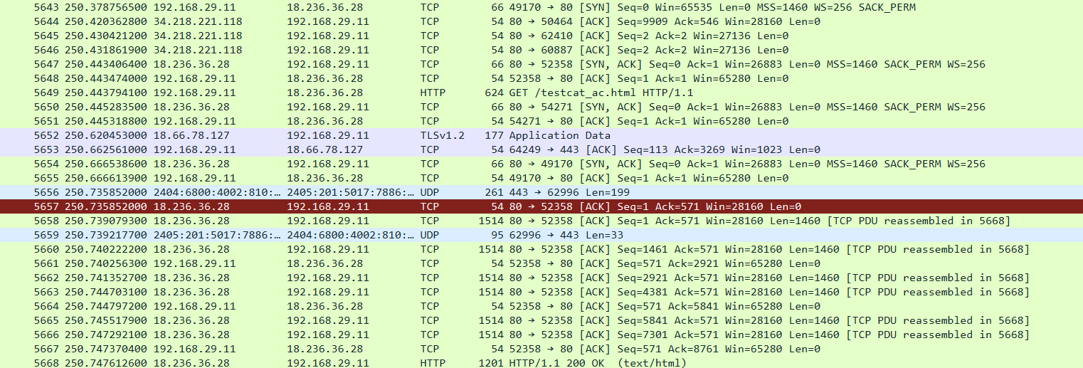
SYN Packet:
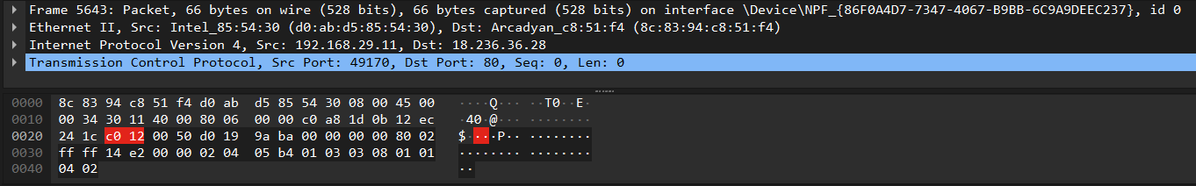

SYN-ACK Packet
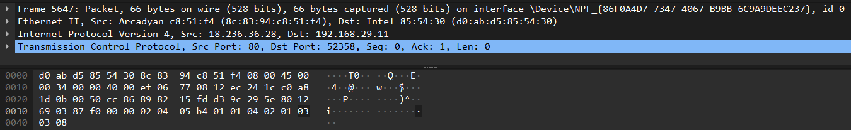

ACK Packet
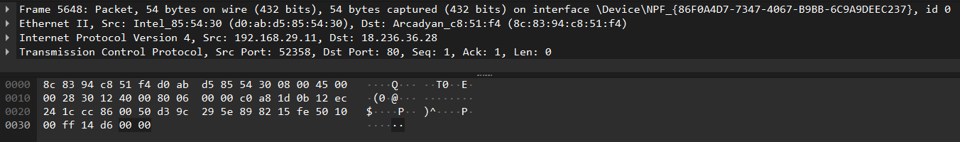

    - To capture and analyze UDP packets

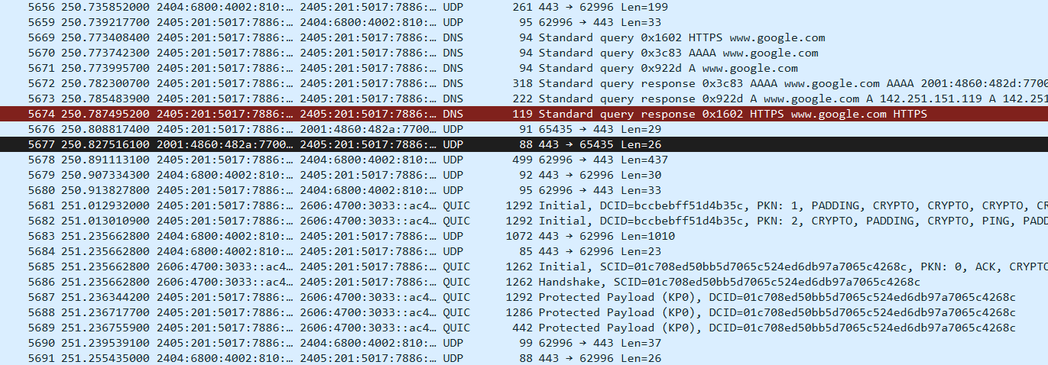

UDP Packet:
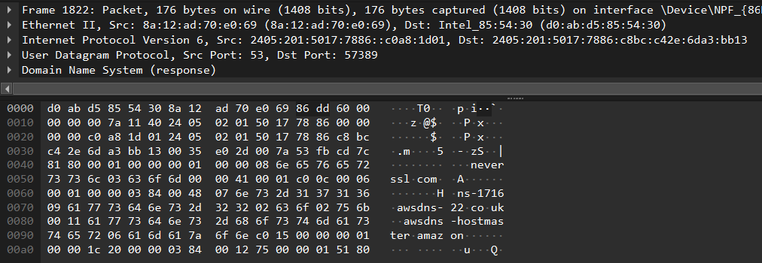

    - To capture and analyze DNS query and response packets

DNS Packet:
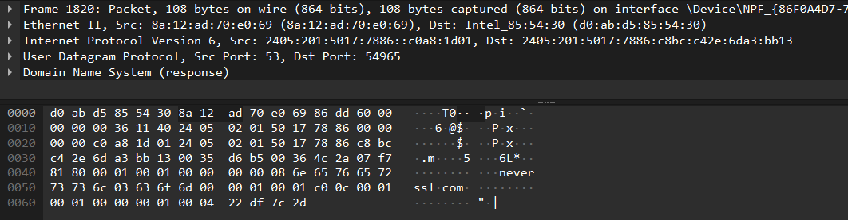

    - To capture and analyze HTTP packets

HTTP Packet:
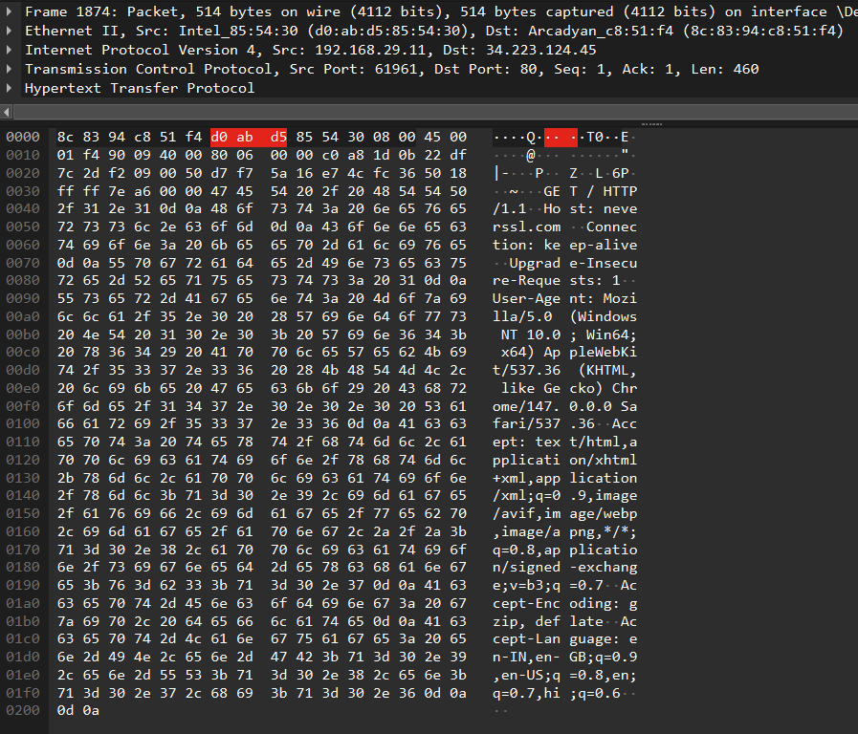

    - To analyze ARP request and reply packets

Request Packets:
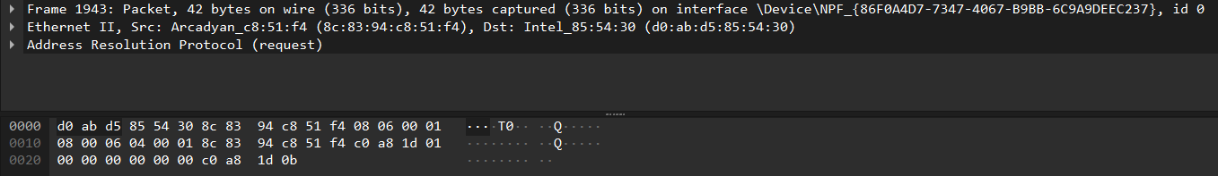

Reply Packets:
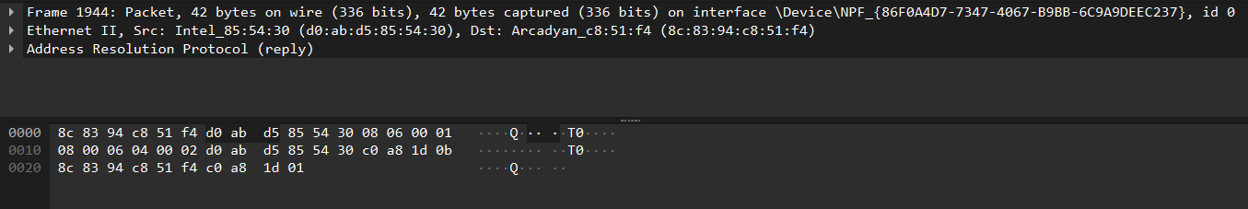

    - To identify source and destination MAC and IP addresses in captured packets

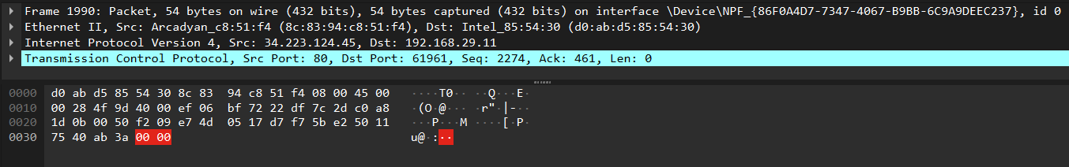
Source MAC address : 8c:83:94:c8:51:f4
Destination MAC address : d0:ab:d5:85:54:30

Source IP address : 34.223.124.45
Destination IP address 192.168.29.11

ASSIGNMENT 3

To create simple Network Topologies Using Cisco Packet Tracer.

Q1.
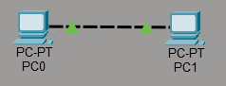

Q2.
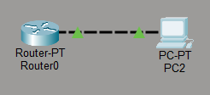

Q3.
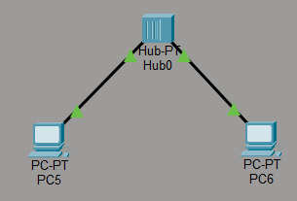

Q4.
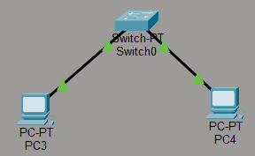
Q5.
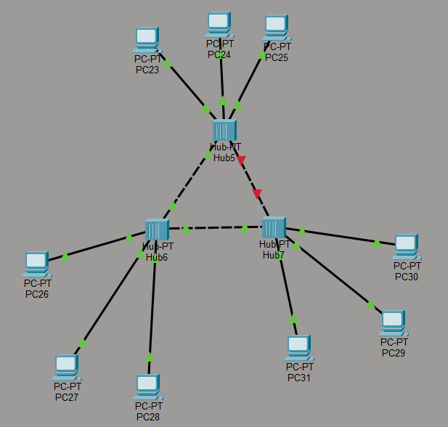
Q7.
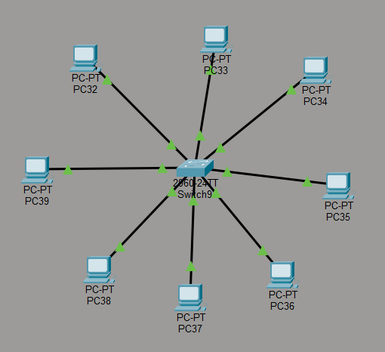
Q8.
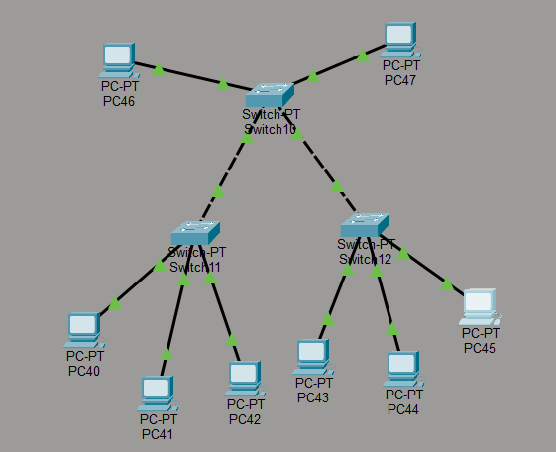

ASSIGNMENT 4

Q.1 Create a pool on the DHCP Server router, named “xyz” and follow all the requirements.
1. Client should use the DNS server with the IP address: 1.2.3.4
2. Client should use the network 192.168.10.0/24
3. Client should renew their IP address after every 3 hours
4. Make sure, Router does not respond to any BOOTP
5. Configure the Client so that it will obtain IP from DHCP server
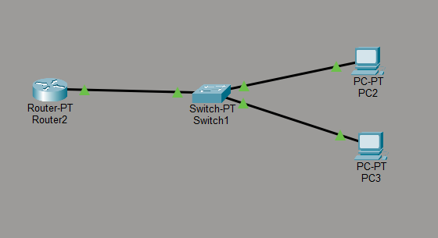

ASSIGNMENT 5
Q1.
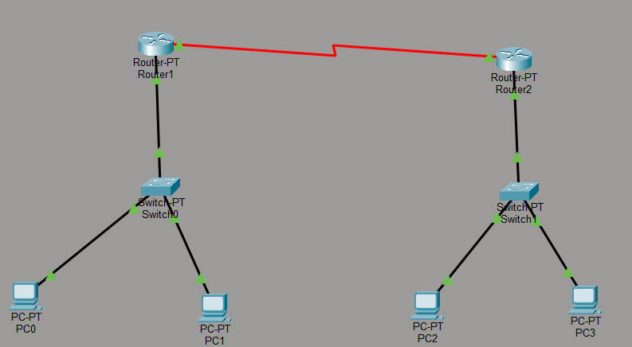
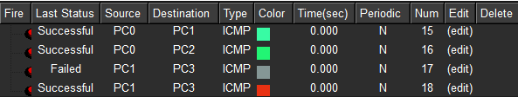
Q2.
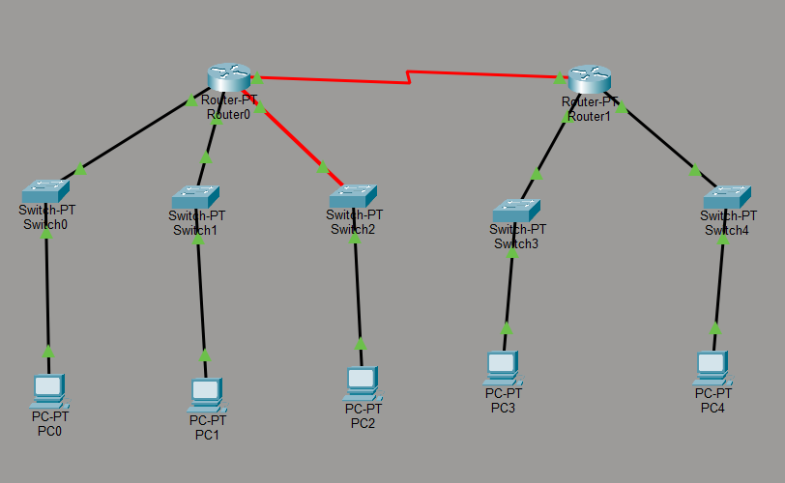
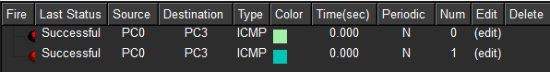

Q3.
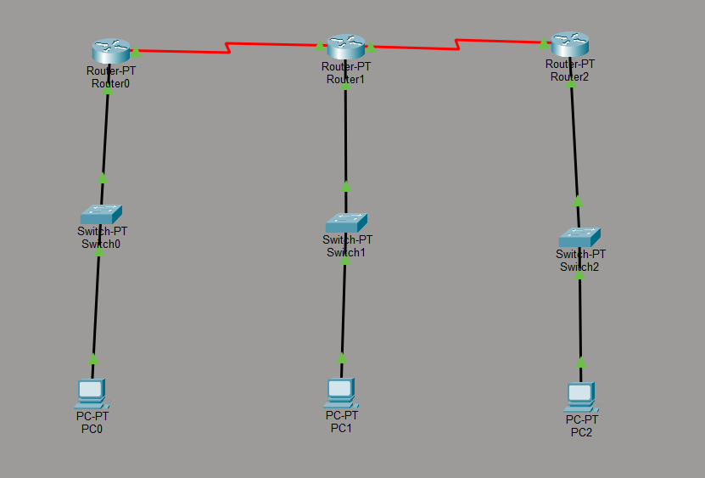
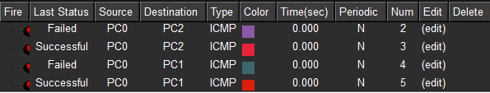

ASSIGNMENT 6

To configure and verify routing using RIP Version 2 protocol in a network.

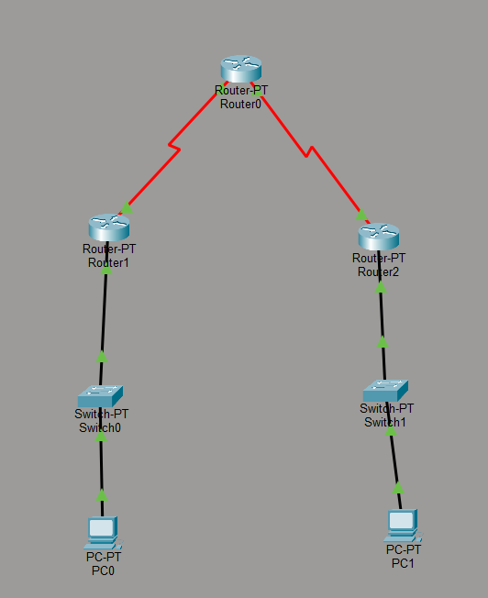
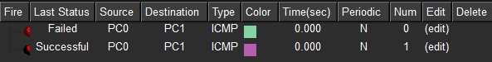
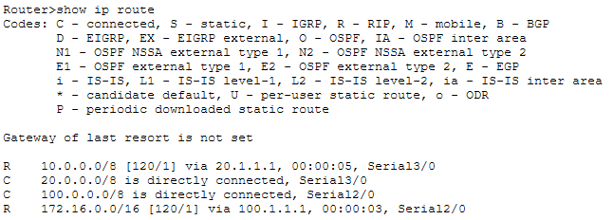
ASSIGNMENT 7

Routing using OSPF (Link State Routing)
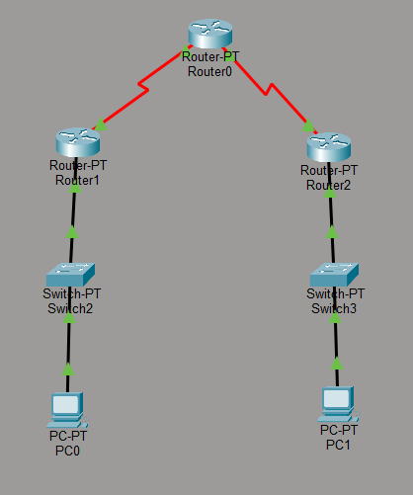
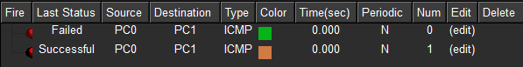
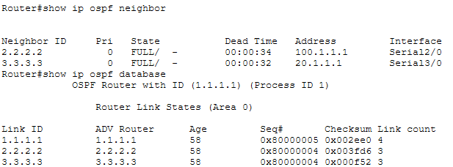

ASSIGNMENT 8

Configuration and Analysis of BGP Routing.
